Guide 3. Final APT Project Report
Capstone Course

1. Final APT Project Report
The objective of this report is for you to describe the most relevant aspects of your APT Project. It is important that you justify the decisions you had to make throughout the process.

Below, you will find different fields that you must complete with the requested information, which provide a summary of your APT project and its main results.

Project name | Siempre Cerca
Area(s) of performance | Mobile development; systems design; project management; systems architecture; systems quality and security; databases.
Competencies | Construction and integration of software solutions; design and execution of tests; planning and control of IT projects; data modeling and implementation; quality and security. Teamwork, problem solving, effective communication, proactivity, and time management were also strengthened.

Final report contents
1. Relevance of the APT project | Currently, a large percentage of older adults live alone or far from their families. This geographical and daily distance creates a constant burden of worry and stress for their children, who fear that their parents might experience medical emergencies, falls, disorientation, or health complications—such as those related to chronic conditions like diabetes—without anyone being there to provide timely assistance.  Given this reality, we decided to create this application as a technological bridge designed to address the specific needs of both parties.  We chose this focus because caring for and monitoring older adults is often complex and challenging, especially when they live alone or are physically distant from their relatives. The lack of communication and the uncertainty that arises from not knowing how they are doing on a day-to-day basis can be distressing; our project provides greater security and peace of mind, particularly during emergencies.  The project will initially focus on Chile—specifically the Metropolitan Region and its surrounding municipalities—where many families face difficulties due to geographical distance, travel time, and work commitments, making it hard to consistently monitor their older relatives. This creates a need for technological tools that can track their location, send alerts, and enable timely action in the event of an emergency. Furthermore, this is not just a challenge in Chile; it is an issue faced by families all over the world.  The problem primarily affects older adults—especially those who live alone, have limited mobility, suffer from chronic illnesses, or are prone to episodes of disorientation.  It also impacts their family members and close circle, who live in a state of constant concern, unsure whether their loved ones are safe. Our application aims to facilitate a prompt response to potential high-risk situations.  The value proposition of this project lies in developing and delivering a solution that promotes both safety and autonomy through a real-time location tracking system. From a social perspective, the application seeks to alleviate family concerns and enable a faster response during critical situations. In a professional context, it represents the practical application of Computer Engineering knowledge to develop digital products aimed at solving real-world problems, incorporating current technologies such as GPS, databases, and various features typical of mobile applications.
2. Objectives | General objective:  The general objective is to develop a mobile application focused on the monitoring and safety of older adults. It aims to enable family members or caregivers to access precise, real-time information regarding the user's location, as well as receive reports on emergencies or incidents—such as falls or disorientation—thereby minimizing risks through rapid, timely responses and reducing concern.  Specific objectives:  - Intuitive design and robust security.  - Integration with a cloud-based database.  - Ability to trigger a sound on the phone to help locate it.  - Emergency button.  - Cloud-based database integration for the secure storage and management of application data.  - Real-time GPS tracking.  - Automated alerts sent to family members.  - Alerts sent to a mobile device if the user leaves a pre-defined "safe zone."  - Display of medical information on the lock screen (name, medical conditions, allergies, emergency contact).  - One-touch guidance for returning home.  - Reminders for daily activities (e.g., blood glucose checks, meals, insulin administration).  - Medication reminders.  - A variety of games to provide entertainment and cognitive stimulation for older adults.  - Voice-guided instructions for older adults with visual impairments.  - Colorblind-friendly mode for improved accessibility.  - Monitoring of vital signs via a mobile phone or smartwatch.
3. Methodology | The project was developed using an agile methodology based on Scrum, adapted to an academic context and a four-member team. Work began with information gathering, requirements definition, the creation of a Product Backlog, architecture design, and prototyping. Subsequently, the process was organized into Sprints, incorporating Sprint Planning, a Sprint Backlog, daily meetings, a Scrum Board (in Trello), a "Definition of Done," Sprint Reviews, and Retrospectives.  Execution was incremental: Sprint 1 established the authentication foundation; Sprint 2 incorporated linking and geolocation features; and Sprint 3 focused on security, tracking, reminders, and other support tools. Throughout this process, the team conducted functional and non-functional testing, bug fixes, and documentation, while also validating the system with older adults from Huechuraba and Quilicura.  The Scrum framework was well-suited for this project, as it allowed for development to be broken down into small, manageable deliverables, provided visibility into progress, ensured traceability via Trello and GitHub, and enabled the adjustment of priorities based on technical challenges and real-world user feedback.
4. Development | Hector:  My involvement focused on non-functional requirements, business rules, creating mockups, developing epics and features, preparing the quality assurance test plan, executing functional and non-functional tests, fixing bugs (in collaboration with another team member), and preparing installation and user manuals. I also participated in tracking Sprints, reviewing results, and updating technical documentation.  Melanie:  My involvement focused primarily on the analysis and requirements-gathering stages, agile management, and validating the proposal. I also participated in evaluating the project's economic viability, taking into account associated costs and the business model. Furthermore, I worked on creating and updating technical documentation, while supporting project planning and progress reviews. I also performed application testing to validate its functionality, identify potential bugs, and ensure that the features met the defined requirements.  Paul:  In the development of "Siempre Cerca," I participated in every stage of the software development life cycle, including analyzing the problem, gathering requirements, designing the architecture and the system, creating mockups, planning and tracking Sprints, developing the database and features, integrating the system, validating the project, evaluating its economic feasibility, and preparing the continuity and maintenance plan.  Angel:  My involvement focused on system architecture and backend development. I was responsible for modeling and implementing the relational database in PostgreSQL using Supabase. Throughout the project, I handled the most technically complex user stories: I configured the authentication system and security—using Row-Level Security (RLS) policies and JWT tokens—and worked on improving the accuracy of the geolocation features. I also dedicated a significant portion of my work to performance optimization, such as reducing the overhead of real-time queries, and resolving code and security issues prior to deployments. Key project stages and activities included:  - Gathering and validating needs with older adults in Huechuraba and Quilicura.  - Defining requirements, architecture, databases, user stories, and the product backlog.  - Iterative development of features such as authentication, user linking, geolocation, SOS functions, safe zones, reminders, accessibility, and cognitive activities.  - Testing, defect management, documentation, manual creation, and evaluation of results.  Enablers: clear distribution of responsibilities; use of tools like Trello, GitHub/GitHub Desktop, Discord, WhatsApp, and Supabase; and validation sessions with users.  Challenges: variations in geolocation accuracy, integration between components, scope creep, and the need for better tracking of hours and changes during Sprints.  Adjustments made: geolocation testing was strengthened, the backlog and documentation were updated, accessibility improvements were implemented, and user stories requiring further development or validation were kept as pending—ensuring they were not marked as complete without meeting their defined criteria.
5. Evidence | The following evidence corresponds to the submitted final report and makes it possible to visualize the evolution from planning and work tracking to the functional product.  Evidence 1. Updated User Story Mapping: shows the organization of the project's user stories and releases.  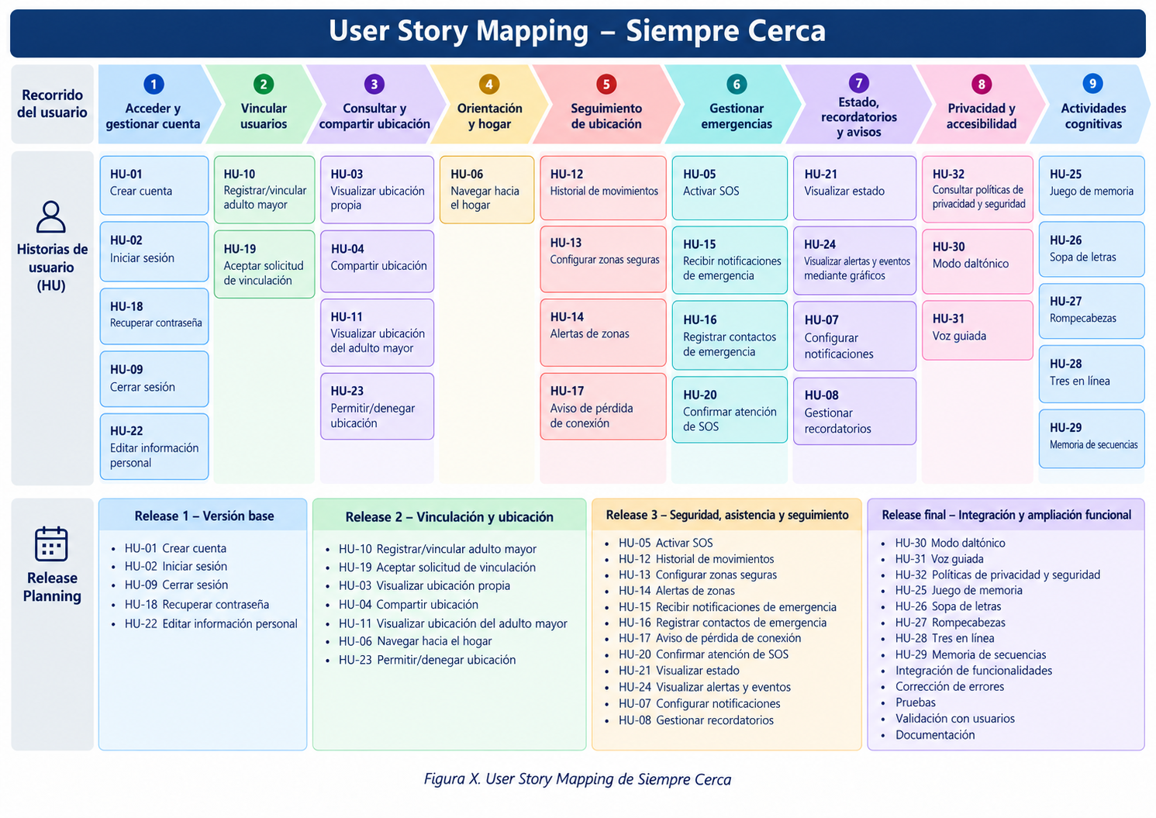  Evidence 2. Scrum Board in Trello: shows task tracking through Backlog/Pending, To Do, In Progress, In Review, and Done.  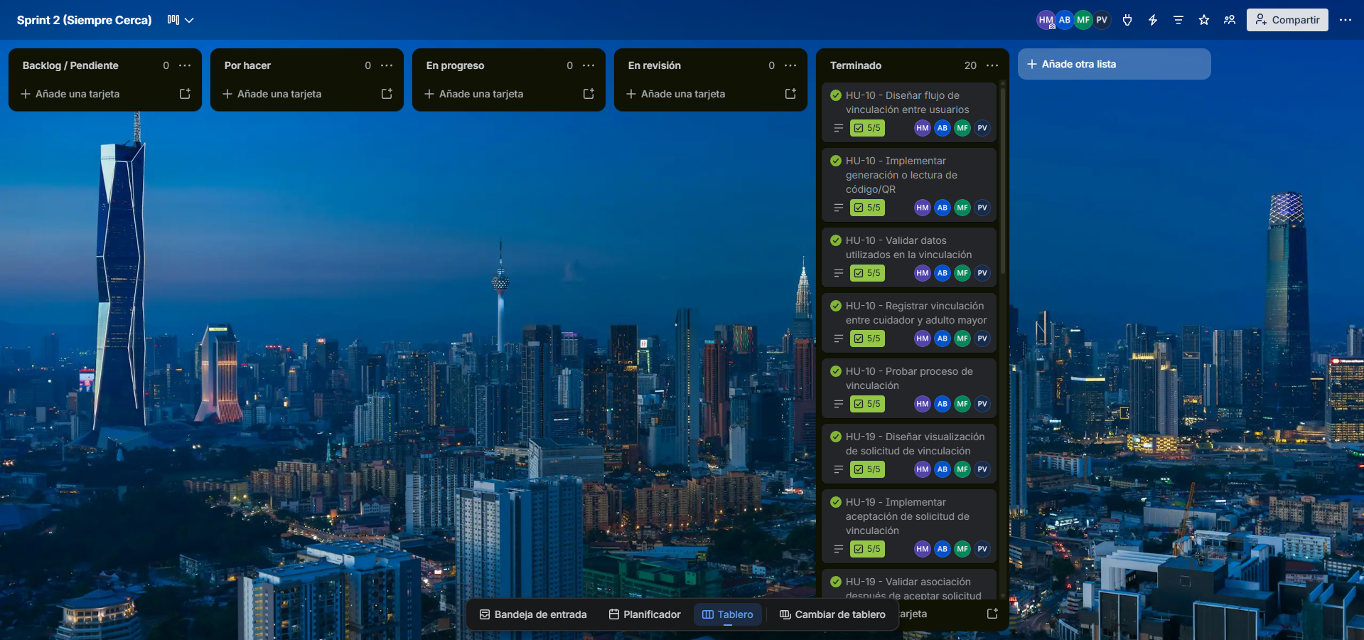  Evidence 3. Functional views of Siempre Cerca: real interfaces for the older adult and caregiver/family member.  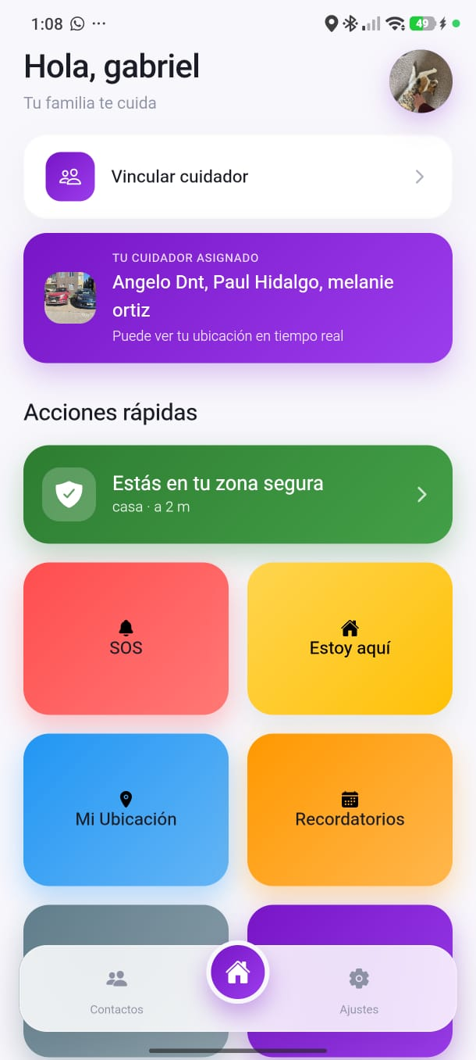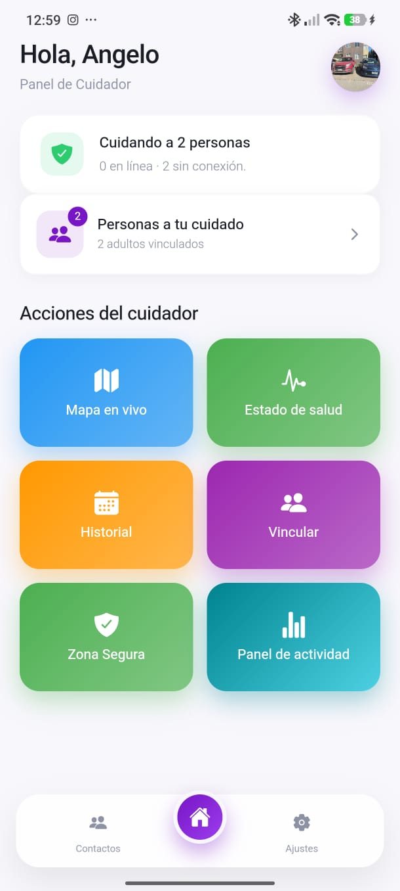  This evidence complements the test cases, defect logs, validation surveys, and technical documentation prepared during the project.
6. Professional interests and career projections | Hector:  "Siempre Cerca" gave me a deeper understanding of how an IT project must integrate development, testing, security, documentation, and user experience. Participating in testing and bug fixing strengthened my interest in software development and quality assurance, while working with Supabase, PostgreSQL, authentication, and geolocation allowed me to apply my knowledge of data integration and management to a real-world solution.  Validating the application with older adults also changed how I evaluate an interface; I realized that a technically sound solution is not enough if the target user struggles to understand it. This reinforced my commitment to developing useful, accessible applications that address real-world needs.  My professional interests remain within the IT field, but this project helped me identify specific areas I would like to explore further—namely software development and integration, databases, quality testing, and security. In my future career, I envision myself working on teams that develop technological solutions, contributing to implementation, validation, and the continuous improvement of systems.  Melanie:  The APT project helped me better define my professional interests, as I was able to apply what I learned during my degree program to the development of "Siempre Cerca." It also gave me a clearer picture of what a project entails—from initial planning to development and testing. My primary interest remains software development—an area I am particularly passionate about—along with data science. Additionally, I would like to learn more about project management to gain a broader understanding and build more experience in that domain.  I want to continue learning about software development, exploring new technologies, and honing my programming skills. I am also interested in project management, as it is a field that appeals to me and is clearly vital to the success of any project. After graduation, I hope to work in the IT sector—ideally in data science—where I can apply what I have learned, gain professional experience, and continue to expand my knowledge. I would also like to explore other areas of computer science to discover new opportunities and determine which one I might want to specialize in later on.  Paul:  Developing the "APT: Siempre Cerca" (Always Close) project allowed me to better understand my professional interests and the entire process of creating a technological solution—from analyzing the underlying problem to implementing and validating the final product. Throughout the project, I was able to apply and strengthen my technical knowledge in application development, interface design, database modeling, feature integration, and the use of various development tools. This experience confirmed my interest in the field of computer science—specifically in software development and systems design—while also highlighting the importance of project planning and management. My professional interests remain focused on technology, and I am now keen to continue learning about software architecture, new tools, and development methodologies. Looking ahead, I envision myself working in the computer science field, participating in real-world projects where I can continue to gain experience, refine my technical skills, and keep growing professionally.  Angel:  The APT project gave me a much clearer perspective on what I am truly passionate about: backend development, systems architecture, and data security. While I was interested in software development in general at the start of the course, tackling complex, real-world challenges—such as optimizing database-heavy queries or ensuring sensitive data remains protected—confirmed that my greatest strength lies in building the "behind-the-scenes" components that are critical to an application’s functionality. I also realized that even the best application design is useless if the underlying features are neither stable nor scalable.  Moving forward, I intend to delve deeper into cloud technologies, advanced database management, and cybersecurity. In my future career, I see myself working within agile development teams as a Backend Developer, focusing on designing robust, high-impact systems that solve real-world problems efficiently and securely.

